**Azure App Services**

Case Study : Deploy a HTML Web Application in Azure App Services

Below are the screenshots of the cloud shell steps followed.

Screenshot 1:

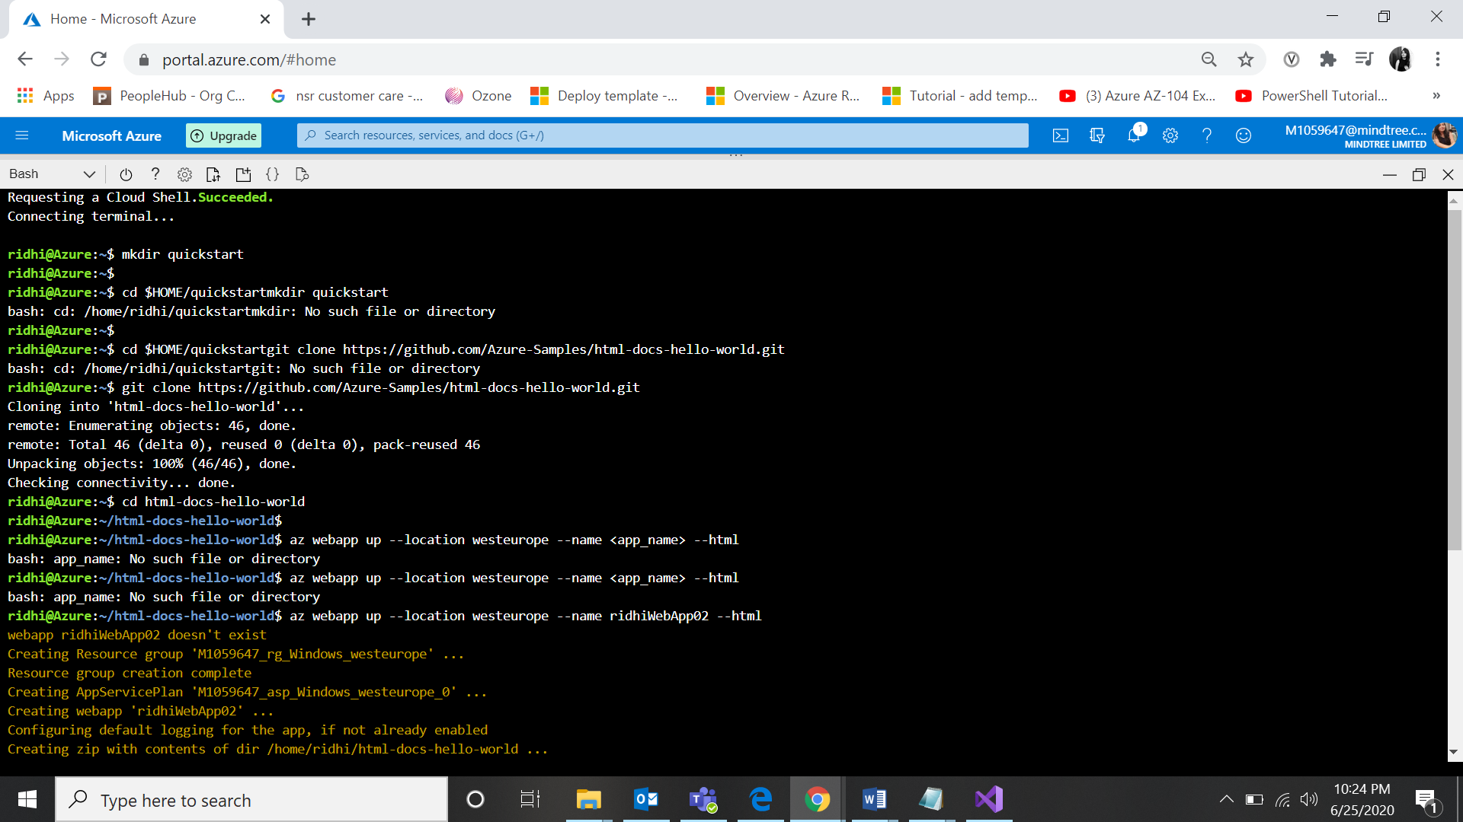

Screenshot 2:

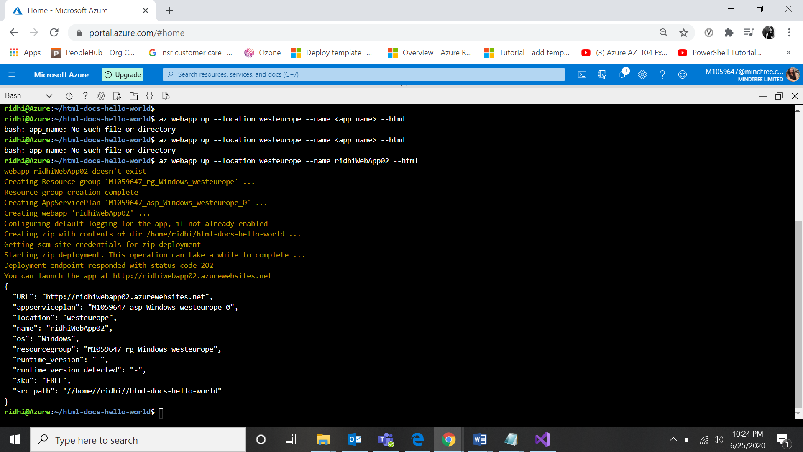

Screenshot 3:

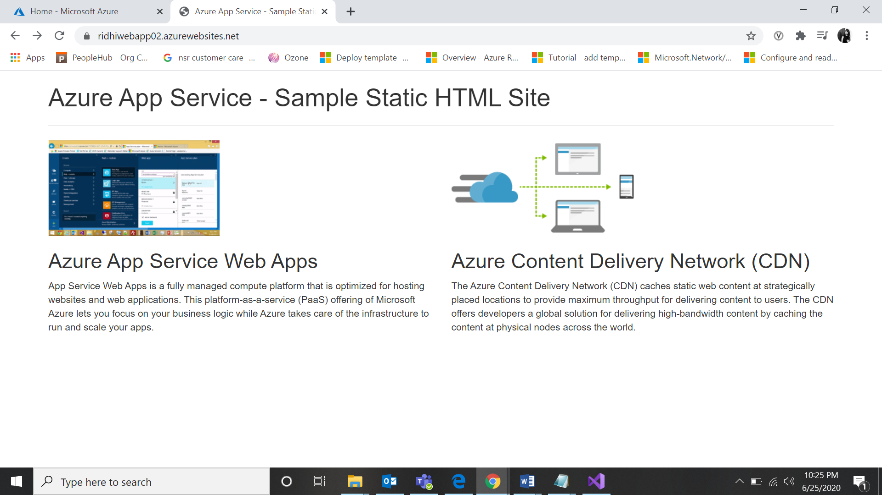

Screenshot 4:

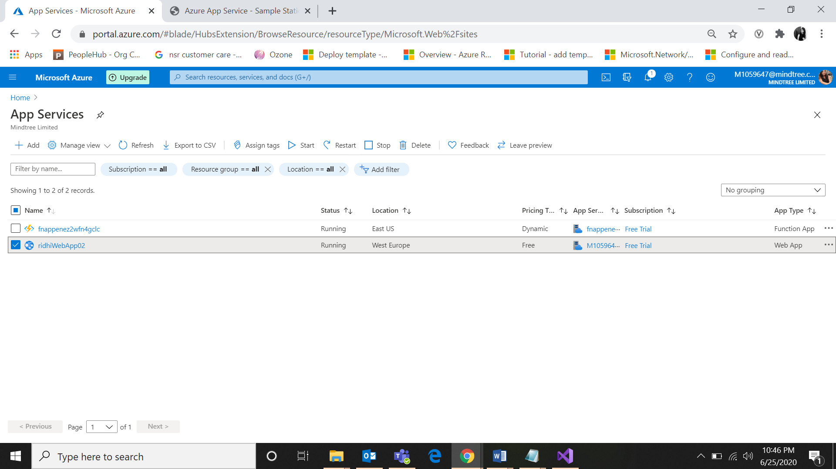

Screenshot 5:

